1. As we know that consumers can read, from partitions, the data in order and as well as in group. We will see this later on.
2. A screenshot of a computer

   Description automatically generated
3. Let’s create a new topic **second_topic** with **partitions=3**, to see the behaviors, if the data is distributed or not. A close up of a text

   Description automatically generated
4. A white background with black text

   Description automatically generated
5. With following Producer Configuration, we will start producing msg where  
   partitioner.class=org.apache.kafka.clients.producer.RoundRobinPartition will be used to distribute msgs one by one to each partition (As we have 3 partitions).  
   This is to show demo when consuming msgs.  
   A screenshot of a computer

   Description automatically generated
6. A screenshot of a computer

   Description automatically generated
7. A blue and green text

   Description automatically generated
8. 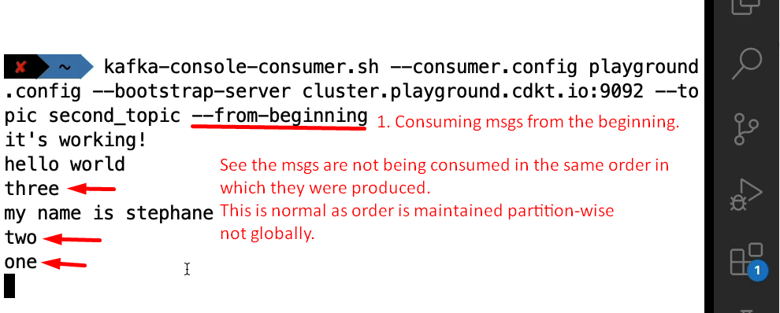
9. Let’s print the other info also like partition#, key, value, timestamp to analyze further when running Console consumer.  
   
10. 